**WEEK-7**

**REACT**

**9. ReactJS-HOL**

**Create a React Application named “cricketapp” with the following components**

**CODE:**

**Step 1: Create the React App**

npx create-react-app cricketapp

cd cricketapp

code .

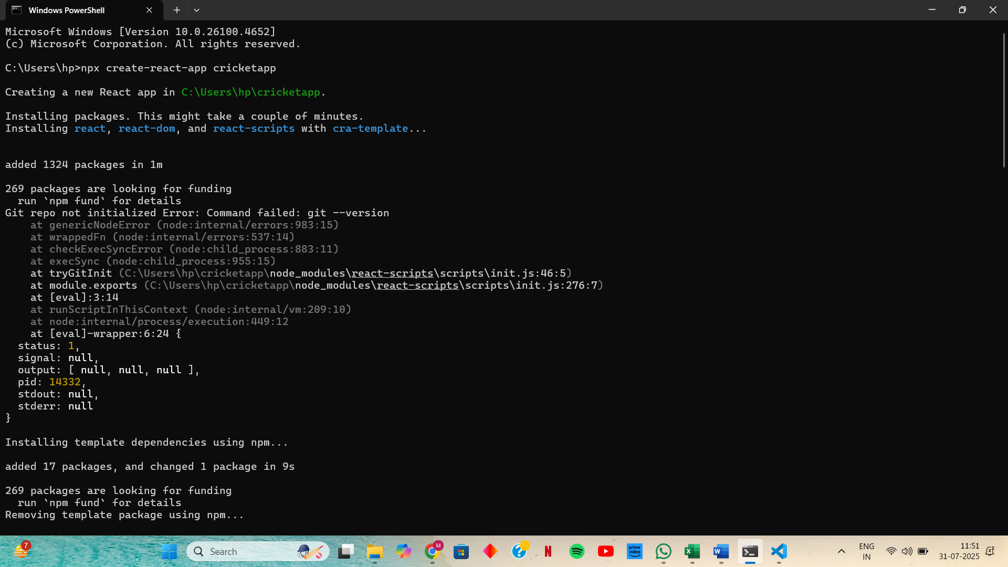

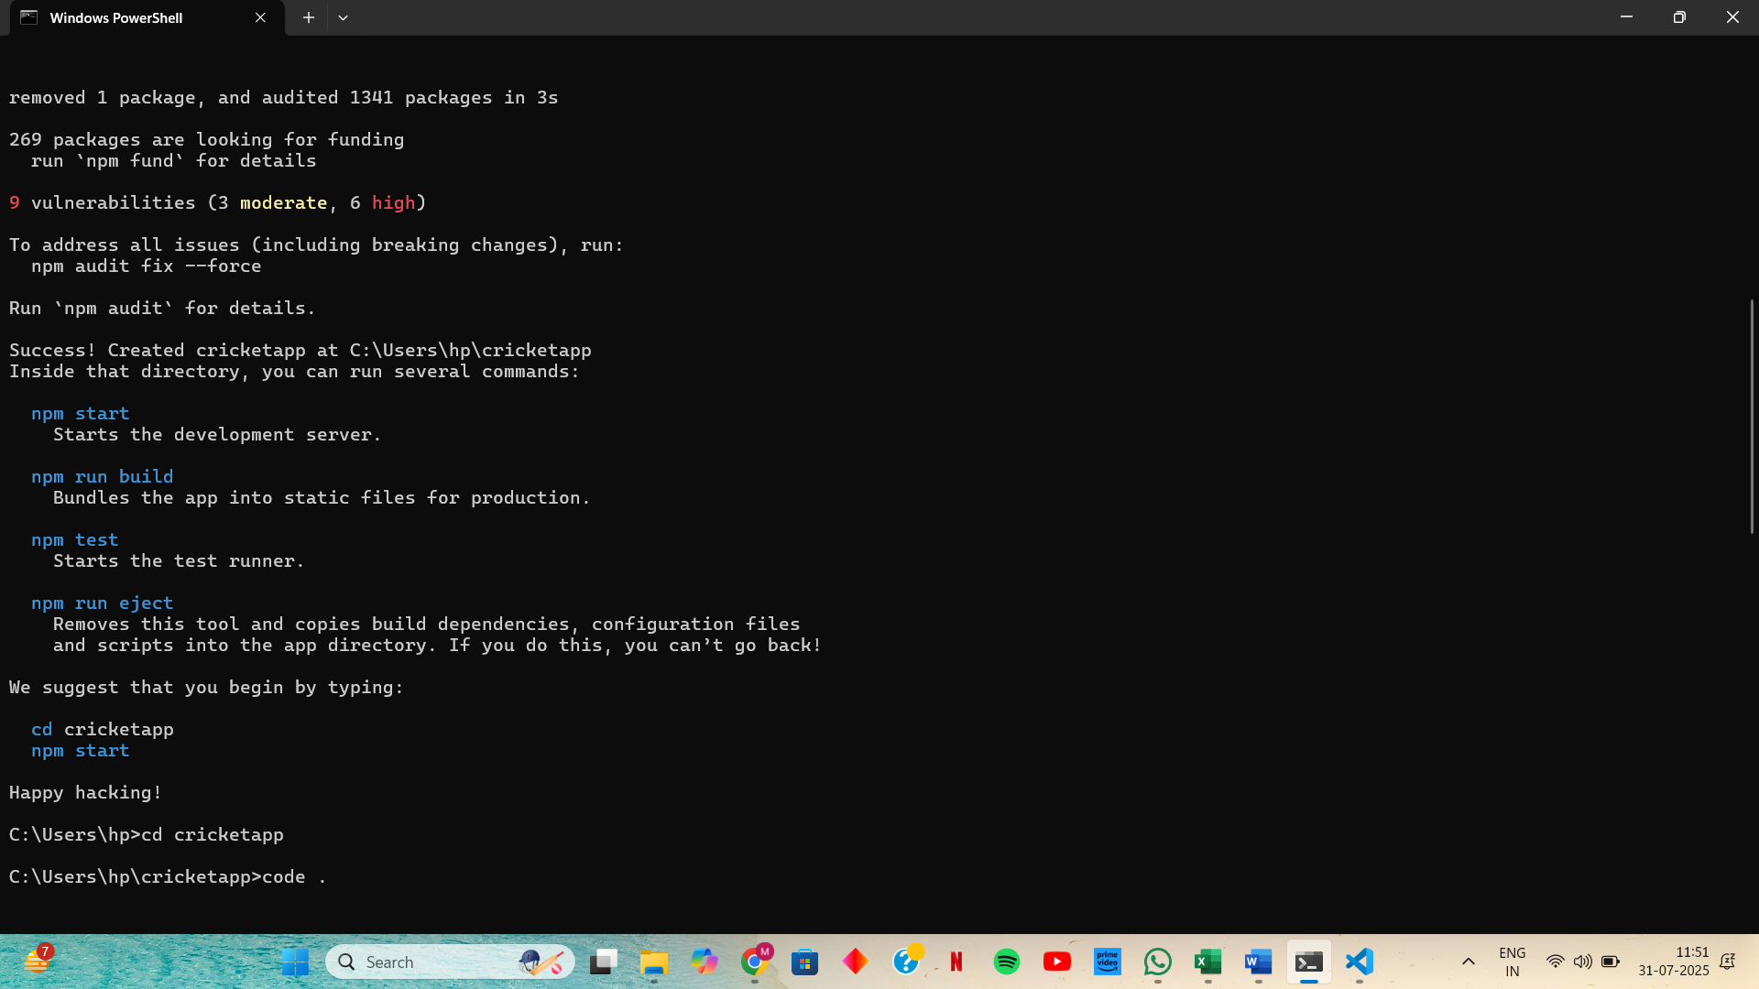

**Step 2: Setup Folder and Files**

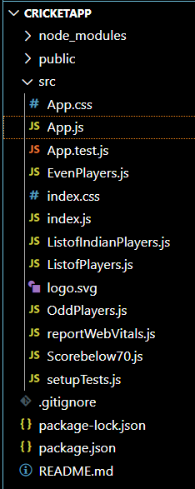

**Step 3: Update App.js**

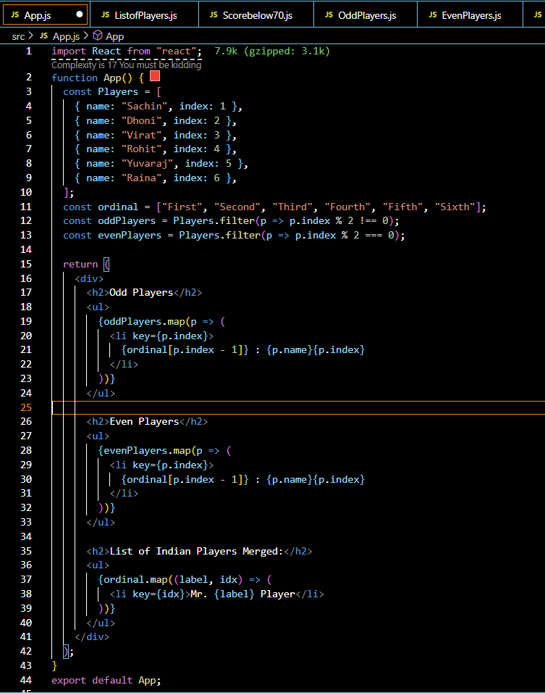

**Step 4: Component - ListofPlayers.js**

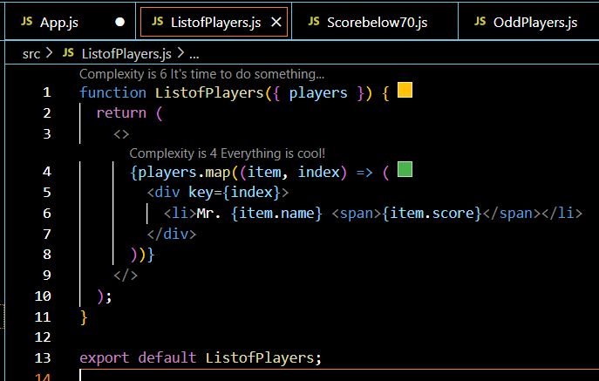

**Step 5: Component - Scorebelow70.js**

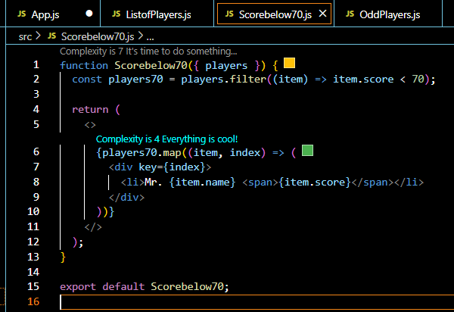

**Step 6: Component - OddPlayers.js**

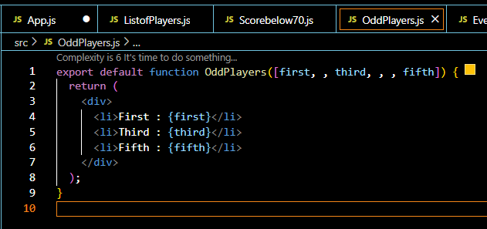

**Step 7: Component - EvenPlayers.js**

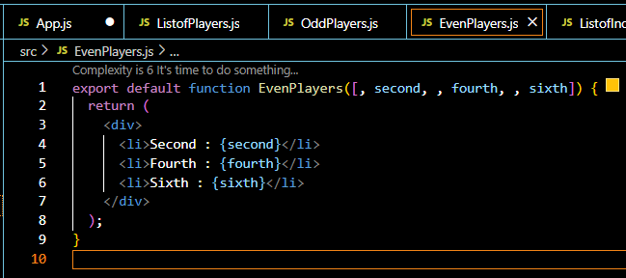

**Step 8: Component - ListofIndianPlayers.js**

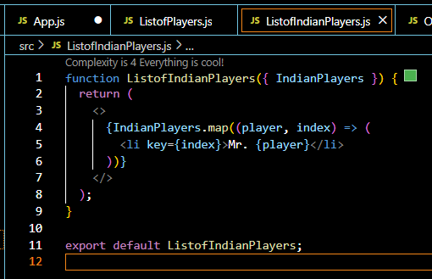

**OUTPUT:**

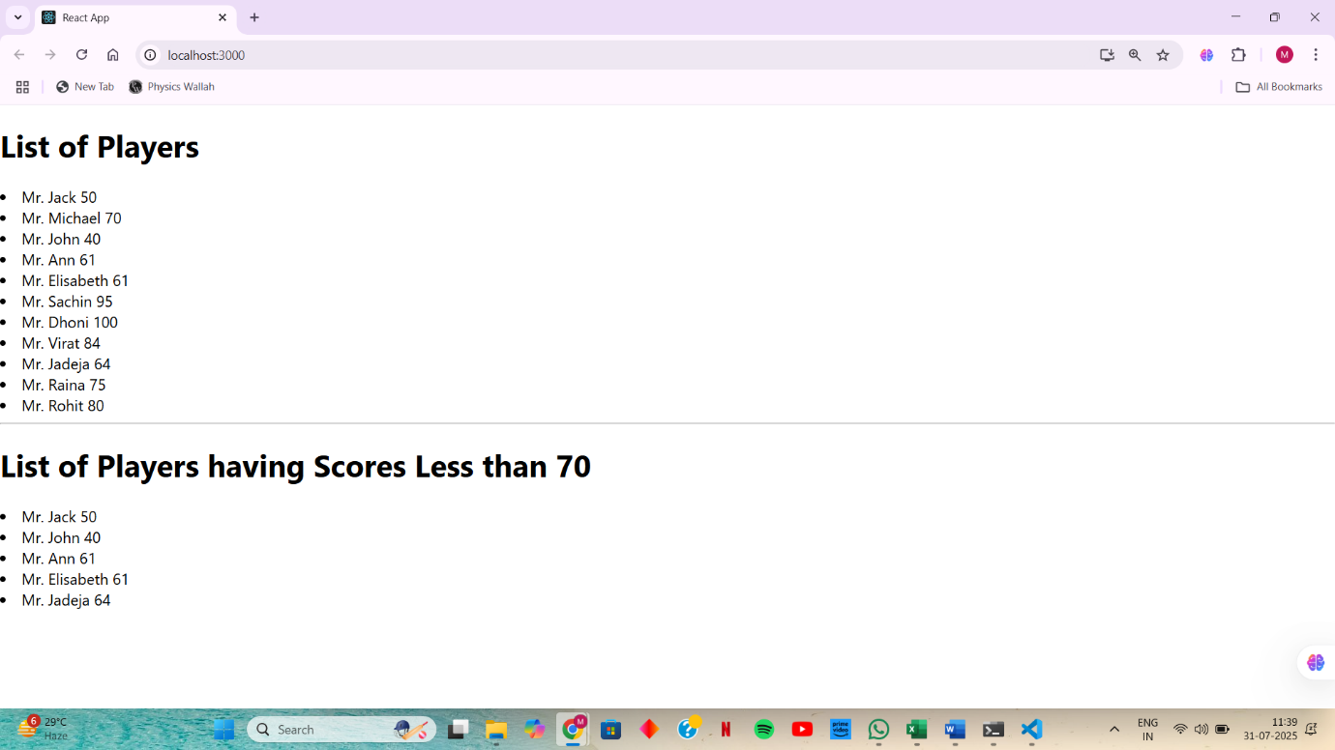

**When the flag = false**

